TASK 01:
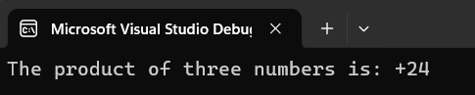

TASK 02:
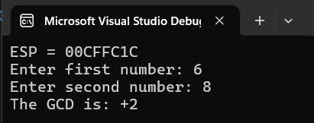

TASK 03:
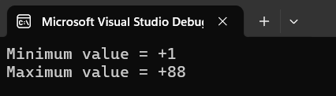

TASK 04:
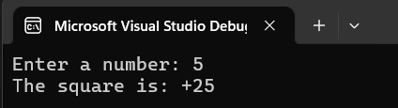

TASK 05:
